Exercise 6 – CSV Processing

Workflow
create_csv
↓
read_csv
↓
calculate_revenue
↓
create_summary

sales.csv
product,quantity,price
Laptop,2,70000
Mouse,5,500
Keyboard,3,1200

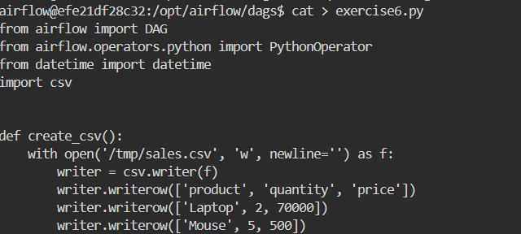

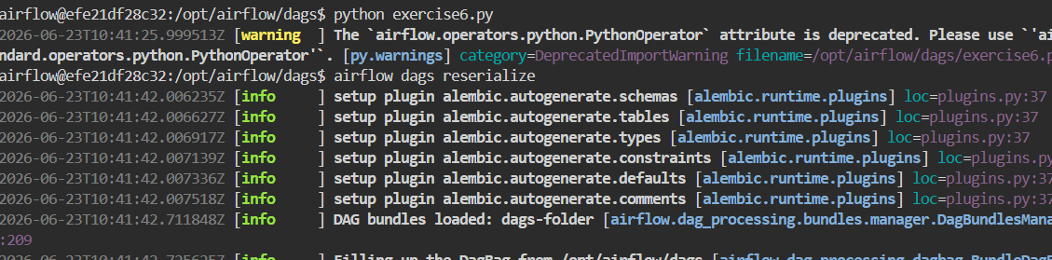

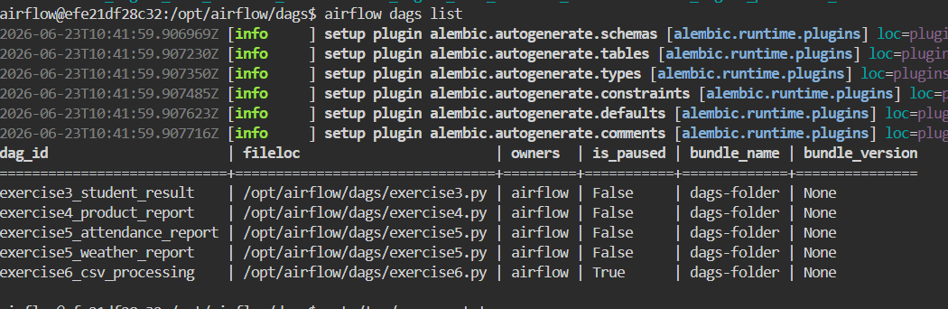

Python Code:
from airflow import DAG
from airflow.operators.python import PythonOperator
from datetime import datetime
import csv

def create_csv():
with open('/tmp/sales.csv', 'w', newline='') as f:
writer = csv.writer(f)
writer.writerow(['product', 'quantity', 'price'])
writer.writerow(['Laptop', 2, 70000])
writer.writerow(['Mouse', 5, 500])
writer.writerow(['Keyboard', 3, 1200])

def read_csv():
with open('/tmp/sales.csv', 'r') as f:
reader = csv.DictReader(f)

with open('/tmp/revenue.txt', 'w') as out:
for row in reader:
revenue = int(row['quantity']) * int(row['price'])
out.write(f"{row['product']}={revenue}\n")

def calculate_revenue():
total_revenue = 0

with open('/tmp/revenue.txt', 'r') as f:
for line in f:
product, revenue = line.strip().split('=')
total_revenue += int(revenue)

with open('/tmp/total_revenue.txt', 'w') as f:
f.write(str(total_revenue))

def create_summary():
with open('/tmp/revenue.txt', 'r') as f:
revenues = f.read()

with open('/tmp/total_revenue.txt', 'r') as f:
total = f.read()

with open('/tmp/summary.txt', 'w') as f:
f.write(
revenues +
f"Total Revenue={total}"
)

with DAG(
dag_id='exercise6_csv_processing',
start_date=datetime(2025, 1, 1),
schedule=None,
catchup=False
) as dag:

task1 = PythonOperator(
task_id='create_csv',
python_callable=create_csv
)

task2 = PythonOperator(
task_id='read_csv',
python_callable=read_csv
)

task3 = PythonOperator(
task_id='calculate_revenue',
python_callable=calculate_revenue
)

task4 = PythonOperator(
task_id='create_summary',
python_callable=create_summary
)

task1 >> task2 >> task3 >> task4

Output:

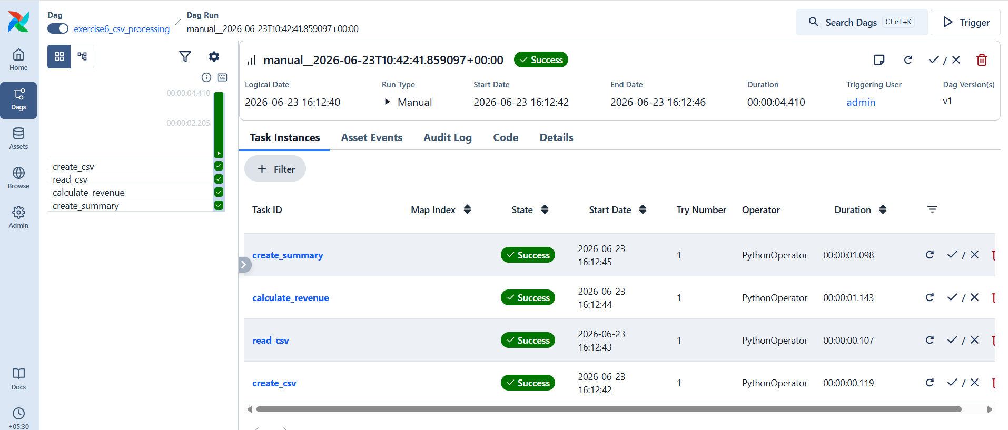

Calculate Revenue
Expected:
Laptop = 140000
Mouse = 2500
Keyboard = 3600
Total Revenue = 146100
